Presentations provide a platform for designers to effectively communicate their creative concepts, ideas, and solutions to clients or other practitioners. This can happen at various stages of the design process, for example, you might present initial sketches at the first stage when you need to assess your understanding of the brief and/or the client’s requirements, or you might present a refined mock-up when you’re seeking final confirmation and sign-off on your creative outcome.



Fig 1. Unsplash (n.d.) Presenting work to a client

Presenting your work also plays a critical role when you’re working with others on a project. Sharing ideas and design concepts helps to get team members on the same page, and allows for peer feedback to help strengthen the final outcome. This is why designers and photographers need to be competent in their presentation skills and be open to feedback. Feedback is regularly required as it helps bridge the gap between the design team’s vision and the client’s expectations all of which ensure clarity and understanding throughout the creative process.

Regardless of when you need to present to colleagues or a client, there is generally a good reason for it.

## 

## The benefits of communicating your work

Presenting your work to others has several advantages. Firstly, it aids decision-making by providing clients and/or team members with the information and insights needed to make informed design choices. Showing your work helps clients evaluate what you’ve offered them (e.g. different design or creative options), which gives them the opportunity to weigh the pros and cons and select their preferred product based on, for instance, their business goals, brand identity, and target audience. During this process your design might receive the validation you require to finalise the outcome, or you may get highly valuable feedback and suggestions that allows you to make the necessary modifications and align your work with the desired outcomes.



Fig 2. Pixabay (n.d.) Feedback is a vital tool towards a successful design

Another reason why it is beneficial to present your work is to build trust and credibility between yourself and your clients. A presentation of your work showcases your technical skills, expertise, professionalism, and commitment to delivering high-quality creative solutions that meet the client's needs and expectations. Communicating your designs can therefore strengthen the client-designer relationship and lay the foundation for successful collaboration on future projects.

Finally, sharing your work with colleagues/team members can foster a strong partnership between creative practitioners working together on a project. Presentations of work provide a platform for open dialogue, creative exchange, and shared decision-making, enabling all parties to work together towards a common goal and achieve the best possible design outcomes.



Fig 3. Unsplash (n.d.) Presentations are the norm in design teams

## The purpose of presentations

Presenting designs to others serves several important purposes:

### Recording

Presentations serve as a record of the creative concepts, ideas, and decisions discussed between the designer/photographer and the client. This purpose is served whether you present to a client or a team, or at the beginning or end of a project. Presentations of your work is a way to document the progression of a project and provides you and your clients with a reference point for future discussions and revisions.

### Collaboration and Teamwork

As mentioned before in this article, presentations facilitate collaboration and teamwork between designers, clients, and other stakeholders involved in a particular project. Whether you share a digital design using software with collaboration tools or a hardcopy presentation, it provides an opportunity for everyone to come together, review the work, share insights, and then proceed to work towards a common design goal.

### Research

Typically at the start of a project, presentations may involve showcasing relevant research findings, insights, and analysis that could guide you or your design team in making decisions conducive to the desired outcome. For example, if you conduct research on market trends or user preferences, it will be important for you to present these findings to others in a team or your client, so that it can inform your design and reach a particular target audience.



Fig 4. Unsplash (n.d.) User experience data

### Pitches

When thinking of a design presentation, the first thing that pops into most people’s head is a pitch. A design pitch is when you formally present your concepts or design proposals to a current or potential client, or employer (e.g. job interview). Pitch presentations help creative practitioners to persuade clients to choose their solutions, or employers to select them for a role or specific project.

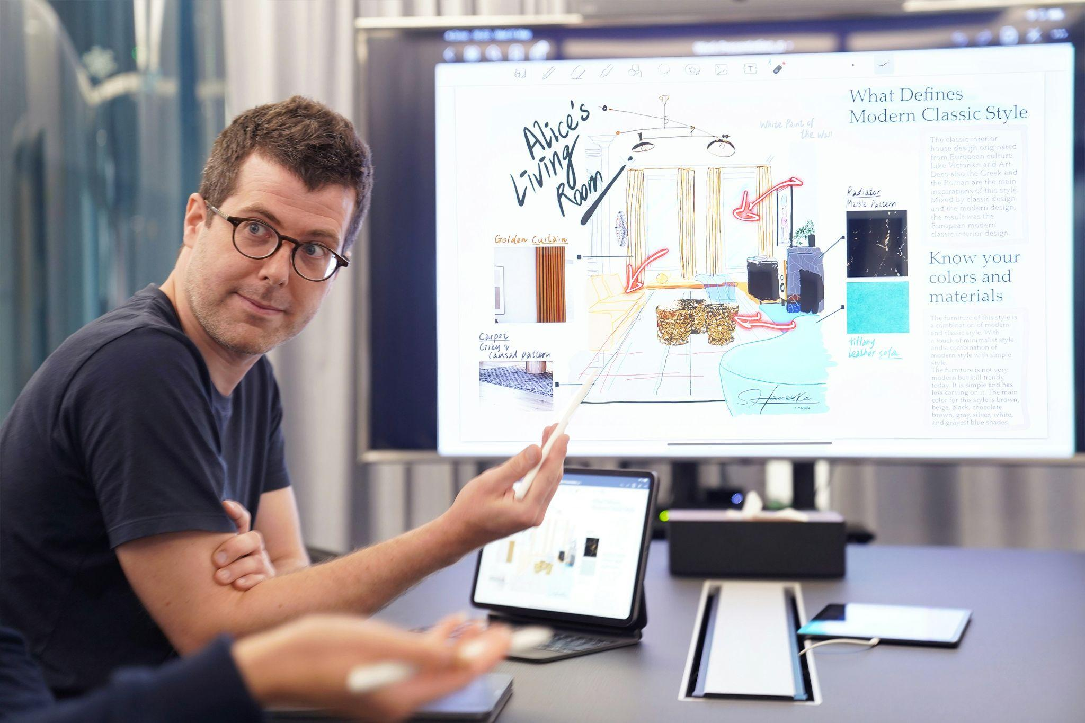

Fig 5. Unsplash (n.d.) Nowadays, it is more common for creative designs to be presented digitally

### Testing and feedback

More often than not, you will present your work to test your creative solutions and elicit feedback from clients, stakeholders or potential users. This could happen several times during the design process. Presenting your work for feedback could be a quick meeting, where you share some sketches or other visuals, or it could be more formalised and involve a lengthier presentation to a room full of stakeholders.



Fig 6. Unsplash (n.d.) Sometimes a hard copy is the best wat to test visual content

In order to elicit feedback you will have to engage in an informal or formal form of interviewing. Here are some tips to consider:

* Make your questions easy to understand and avoid leading questions.
* Questions should be designed to be responded to with spontaneous and insightful responses.
* Remain as neutral as possible while asking your clients or teammembers questions.
* Stay on-topic throughout the interview, while allowing unexpected relevant information to be explored.
* Ask one question at a time.
* Cover the same range of information in all interviews.

The purpose of any testing session is to give others an opportunity to express their preferences and/or offer suggestions. The latter, albeit nerve wracking, is the aim, so remind yourself that any feedback is input that can help shape the direction of the design project to a more favourable outcome.

### Outcomes and sign-off

Towards the end of the design process, presentations can serve as a way to communicate the final outcomes and benefits of the creative solutions to a client or other stakeholder. These presentations highlight how the visual mock-ups/designs address the client's requirements and goals; how they target user or audience needs, and project needs, and demonstrate the value your designs bring to the client's business or organisation. Part of a final presentation’s goal is to also get a client to sign off on the creative concepts presented. They provide an opportunity for clients to review the designs, ask questions, and provide final approval before moving forward with the production phase of the project.